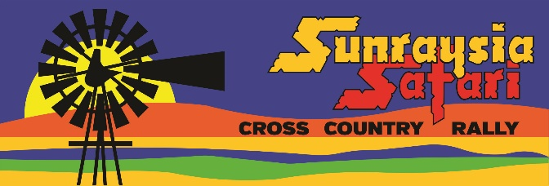
2025 SUNRAYSIA SAFARI
NOMINATION INFORMATION
SEPTEMBER 10-13, 2025
WENTWORTH SHIRE

- ENTRIES STRICTLY LIMITED TO 90 IN TOTAL (IE. MOTO AND AUTO COMBINED)

- TOTAL COMPETITIVE DISTANCE TO BE AROUND 1200kms ACROSS 4 DAYS OF COMPETITION (AS PER PREVIOUS YEARS).

- ALL VEHICLES THAT WERE ELIGIBLE TO COMPETE IN 2024 WILL BE ELIGIBLE IN 2025 (SPECIFIC CLASSES MAY BE SUBJECT TO CHANGES IN LINE WITH UPDATED REGULATIONS). THERE MAY NOT BE A SPECIFIC “RALLY” DIVISION CONDUCTED (SUBJECT TO PREVAILING WEATHER AND COURSE CONDITIONS), BUT RALLY CARS CAN STILL ENTER IN THE AUTO DIVISION IN THE “RALLY” CLASS (FOR PRC/CRC/HISTORIC RALLY CARS).

- EARLY BIRD ENTRY FEE INTRODUCED TO KEEP COSTS AS LOW AS POSSIBLE FOR COMPETITORS. 2025 ENTRY FEE (EARLY BIRD) WILL BE $3000 FOR MOTO, $4000 FOR AUTO, WHICH INCLUDES THE $500 NOMINATION FEE. NOMINATION FEE PAYABLE IMMEDIATELY TO GUARANTEE A PLACE, BALANCE PAYABLE PRIOR TO MAY 30, 2025. ENTRY FEE AFTER MAY 16 WILL BE $3500 FOR MOTO, $4500 FOR AUTO.

- AFTER 90 NOMINATIONS ARE RECEIVED, COMPETITORS WILL GO ONTO THE “STANDBY” LIST, IN ORDER OF NOMINATIONS RECEIVED. THERE IS NO FEE PAYABLE TO BE ON THE “STANDBY” LIST, AND IF COMPETITORS WHO HAVE SUCCESFULLY NOMINATED HAVE NOT COMPLETED THEIR ENTRY FORM AND PAYMENT OF ENTRY FEE BY MAY 23, 2025, THEY WILL LOSE THEIR GUARANTEED ENTRY, AND THOSE ON THE “STANDBY” LIST WILL BE INVITED TO ENTER. NOTE THERE WILL BE A “GRACE” PERIOD FOR COMPETITORS TO PAY THE “EARLY BIRD” ENTRY AMOUNT IF THEY ARE OFFERED A PLACE AFTER MAY 30, 2025.

- THE $500 NOMINATION FEE IS NOT REFUNDABLE, AND NOT TRANSFERRABLE.

- ENTRIES WILL OFFICIALLY OPEN IN EARLY 2025, ONCE REGULATIONS ARE APPROVED BY THE RELEVANT SANCTIONING BODIES.

